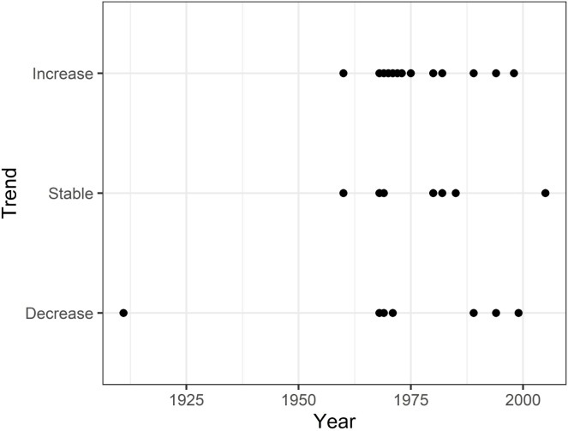Appendix A

***Supplementary Fig. 1.*** *Relationship between the starting year of a study and the sign of the temporal trend.*

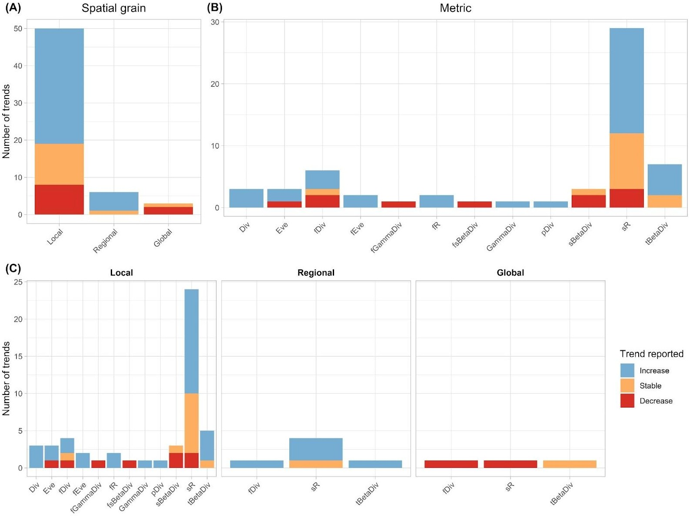

**Supplementary Fig. 2.** Numbers of trends in each category (increase, stable, decrease) for the 59 trends across 24 articles. Note that each trend is an average trend from a given study, scale, and for a given metric, calculated over multiple sites (i.e. spatial replicates). We also note that some trends reported here are based on the same dataset, but come from different studies; this is a potential source of pseudoreplication. For summary of trends that accounts for this pseudoreplication see Fig. 3. Abbreviations: species richness (sR), functional richness (fR), evenness (Eve), functional evenness (fEve), taxonomic diversity (Div), functional diversity (fDiv), temporal beta-diversity (tBetaDiv), spatial beta-diversity (sBetaDiv), functional spatial beta- diversity (fsBetaDiv), gamma-diversity (GammaDiv), functional gamma-diversity (fGammaDiv), phylogenetic diversity (pDiv).

**Supplementary Table 1:** table containing the notes about the trends and articles used in this literature review. Abbreviations: BBS = Breeding Bird Survey, species richness (sR), functional richness (fR), evenness (Eve), functional evenness (fEve), diversity (Div), functional diversity (fDiv), temporal beta-diversity (tBetaDiv), spatial beta-diversity (sBetaDiv), functional spatial beta-diversity (fsBetaDiv), gamma-diversity (GammaDiv), functional gamma-diversity (fGammaDiv), phylogenetic diversity (pDiv).

|  |  |  |  |
| --- | --- | --- | --- |
| Reference | Metric | Spatial grain (km²) | Note |
| Barnagaud *et al.* (2017) | fR | Local | North American BBS, there are 50 census points sampled for 3 minutes, Mean change of SR at the road scales. Area of the road = (40/0.8)*(pi*0.4^2) with a road of 40 Km with point counts spaced by 0.8 Km and a census radius of 400m |
|  | fEve | Local |  |
|  | Eve | Local |  |
|  | sR | Local |  |
| Chase *et al.*  (2019) | sR | Local | North American BBS restricted to a rectangle between 95°W to 70°W and 30°N to 50°N. They binned by 5 years and by quadrats, so the temporal grain of the metric should be different than from the sampling plan |
|  | sR | Regional |  |
| Davey *et al.*  (2012) | Div | Local | British BBS. Metric = Simpson. They predict the metric using a GAM with spatial resolution of 1 Km². Then they show the trend for the mean value of the metric per year |
|  | Eve | Local |  |
|  | sR | Local |  |
| Jarzyna & Jetz (2018) | sR | Local | North American BBS |

|  |  |  |  |
| --- | --- | --- | --- |
|  | sR | Regional |  |
|  | sR | Global | Data from Szabo *et al.* 2012 |
|  | fDiv | Local |  |
|  | fDiv | Regional |  |
|  | fDiv | Global | Data from Szabo *et al.* 2012 |
|  | tBetaDiv | Local |  |
|  | tBetaDiv | Regional |  |
|  | tBetaDiv | Global | Data from Szabo *et al.* 2012 |
| Pilotto *et al.*  (2020) | Div | Local | Metric = Simpson |
|  | sR | Local |  |
|  | tBetaDiv | Local |  |
| Ram *et al.*  (2017) | sR | Local | Swedish BBS, "The number of observations for each sampling route is the sum of observed pair equivalents of birds at the counting points (5 min counting period at each point) and while moving between counting points". SR for forest species meaned over roads, spatial grain = 8* .4 with road of 8 Km and census radius "no limitations" so assumed 200m. |
| Reif *et al.*  (2013) | sBetaDiv | Local | Breeding Bird Monitoring Programme. Jaccard similarity index (pairwise comparisons between transects), first increase then decrease. "A census transect consists of 20 points, which are visited twice per breeding season to sample early and late breeders. Observers register all birds seen or heard for 5 min at each census point" |
|  | sR | Local | "species richness on both the local and national scales did not show any clear temporal trend" |
| Schipper *et al.* (2016) | Div | Local | North American BBS. Metric = Shannon. The metric is meaned over each road. Area of the road = 50*(pi*400^2) with 50 census points per road and a census radius of 400m |
|  | fDiv | Local |  |
|  | fEve | Local |  |

|  |  |  |  |
| --- | --- | --- | --- |
|  | fR | Local |  |
|  | sR | Local |  |
| La Sorte & Boecklen (2005) | Eve | Local | North American BBS. The metric is meaned over each road. Area of the road = 50*(pi*400\^2) with 50 census point per road and a census radius of 400m. |
|  | sR | Local |  |
| Van Turnhout  *et al.* (2007) | sR | Regional | Dutch BBS, " two census periods". For each region, the trend is computed using the mean number of species per atlas square |
|  | sR | Local | Mainly increase of SR but the proportion of negative trend were higher than for the regional scale |
| Wretenberg  *et al.* (2010) | sR | Local | "All sites were visited six times in 1994 and five times in 2004 during early morning". Looking at the trend through different environmental policies, " local species richness (i.e. at the scale of sites = 3 hectares) decreased significantly probably as a result of an overall reduced abundance of several species. " |
| Keller *et al.*  (2020) | sR | Local | Change in number of species between EBBA1 (1972-1995) and EBBA2 (2013-2017), grid cell = 50*50 Km |
| Monnet *et al.*  (2014) | sR | Local | French BBS, Metrics are modelled at the point and site scales with GAMMs, Beta-diversity at the point scale (no indications of the spatial scale so assuming a 200m radius so spatial scale = pi*0.2^2) and gamma-diversity at the site scale |
|  | sBetaDiv | Local |  |
|  | fsBetaDiv | Local |  |
|  | GammaDiv | Local |  |
|  | fGammaDiv | Local |  |
| Spasov *et al.*  (2017) | sR | Local | Trend of the mean species richness per study plot, "The mean abundance of birds per sample declined over the years (Table 2, Fig. 3) but there was no significant trend in species richness (Table 2)." Unclear temporal grain: "All birds seen or heard while walking along the two line transects were counted" |
| Jarzyna & Jetz (2017) | sR | Local | American BBS, trend at the road scale. For taxonomic diversity trend: "35 years of significant increase and 7 years of significant decrease" |
|  | fDiv | Local | Functional diversity resulting from summing the length of the branches of a pruned clustering tree |
|  | pDiv | Local |  |

|  |  |  |  |
| --- | --- | --- | --- |
| Tingley & Beissinger (2013) | sR | Local | Spatial grain: 10 counting points per site, with radius of observation assumed to 200m = 10x(pi x 0.2^2). "Modern species richness was significantly less than historical richness (i.e., 95% credible intervals of richness differences nonoverlapping with 0) at 21 sites (27%), while only seven sites (9%) gained a significant number of species. More generally, using mean posterior estimates of richness change, significantly more sites lost species than gained species (57% vs. 43%; χ2 test, P = 0.007)." |
| La Sorte *et al.*  (2009) | sR | Local | North American BBS, "our findings indicate a general trend of increasing species richness" |
| La Sorte (2006) | sR | Local | North American BBS, "In general, the results indicate that, during the time of the survey, more species expanded their geographical ranges within the study area" |
| Ma *et al.*  (2012) | sR | Local | New York State Breeding Bird Atlas |
| Dornelas *et al.* (2014) | sR | Local | For species richness, Fig. S5 shows the slope for birds. For the temporal beta-diversity, trends only for birds is not given so we took the global trend. |
|  | tBetaDiv | Local | Index used Jaccard similarity index. In this review, temporal beta-diversity is assessed as dissimilarity. |
| García-Navas  *et al.* (2020) | sBetaDiv | Local | Sørensen score |
| Blowes *et al.*  (2019) | sR | Local | Temporal extent is the median time serie. Tropical realm is represented only by 5 trends, so we decided to not take it into account. |
|  | sR | Local |  |
|  | tBetaDiv | Local |  |
|  | tBetaDiv | Local |  |
| McGill *et al.*  (2015) | sR | Regional | North American BBS, spatial grain of 5x5° |
|  | sR | Local |  |
| Petchey *et al.*  (2007) | sR | Local | Summer (breeding) distribution of the British avifauna, 2298 grid cells of 10*10 Km. "Species richness [...] from [...] (mean ± 1 SD = 80·6 ± 13·1) in Atlas 1 and from [...] (80·0  ± 15·2) in Atlas 2. " |
|  | fDiv | Local | "FD ranged from […](mean ± 1 SD = 0·58 ± 0·08) in Atlas 1 and from [...] (mean ± 1 SD = 0·59 ± 0·09) in Atlas 2" |